Do you have experience in
teaching GCSE English?
Would you like to volunteer
at our Homework Club?
Join our friendly and welcoming charity in its 25th year
supporting asylum seekers and refugees across Suffolk

We are looking for experienced tutors or teachers to lead English GCSE
and ESOL classes at our weekly Homework Club in Ipswich
Tuesdays 4.30 – 6.30pm
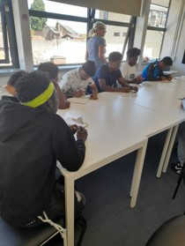

You’ll be
- qualified or experienced in teaching GCSE English
- able to attend once a week during termtime
- friendly and patient
- over 18
- calm and professional
- able to work independently and as part of a team
Knowledge of the asylum system and a second language helpful but not essential.
We ask volunteers for this role to provide references, and undergo an Enhanced Child & Adult DBS check, and complete Safeguarding and Policy training (we provide these)
For an application form please email
lruffle@suffolkrefugee.org.uk

